Form 5916 Screening Guide/Instructions
Applicant/Contractor Screening Criteria
4-2021

Purpose
Texas Health and Human Services Commission (HHSC) uses this form to demonstrate diligence in ensuring that any legal entity contacted (or applying to become a contractor) to deliver services to elderly Texans or Texans with disabilities meets all qualifications in accordance with federal and state rules and regulations. HHSC uses this form to verify that contract applicants and contractors meet criteria to provide the program services listed below.
- Adult Foster Care (AFC)
- Community Living Assistance and Support Services (CLASS)
- Consumer Directed Services (CDS)
- Day Activity and Health Services (DAHS)
- Deaf Blind with Multiple Disabilities (DBMD)
- Emergency Response Services (ERS)
- Guardianship
- Home and Community based Services (HCS)
- Home Delivered Meals (HDM)
- Hospice
- Intermediate Care Facilities for Individuals with an Intellectual Disability or Related Conditions (ICF/IID)
- Nursing Facilities (NF)
- Primary Home Care/Family Care/Community Attendant Services (PHC/FC/CAS)
- Residential Care (RC)
- Swing Beds
- Texas Home Living (TxHmL)
- Transition Assistance Services (TAS)

Procedure

When to Prepare
HHSC staff completes Form 5916 when conducting any of the following activities:
 | AFC, CDS, CLASS, DAHS, DBMD, ERS, HDM, PHC/FC/CAS, RC  and TAS | HCS, Hospice and TxHmL | ICF/IID | Nursing Facilities and Swing Beds | Guardianship
Contract Enrollment/Re-enrollment | Yes | Yes | Yes | Yes | Yes
Change in Ownership/  Legal Entity | Yes | Yes | Yes | Yes | Yes
Change in Controlling Ownership Interest* | Yes | Yes | Yes | Yes | Yes
Formal or Intermittent Monitoring | Yes |  |  |  | Yes
Note: Staff may use the “Other” data entry field to specify any other reason for completing Form 5916.
*Contractors are required to report changes to directors, partners, members, officers, trustees and managing employees of the legal entity, as well as changes to individuals and business entities that have a controlling ownership interest in the legal entity.
Form 5916 may be completed electronically or in ink.

Number of Copies
Complete one original for each activity.

Form Retention
If the legal entity has a contract with HHSC, retain Form 5916 and attachments in accordance with the records retention requirements in the Health and Human Services (HHS) System Procurement and Contract Management Handbook.
If the legal entity is awarded a contract with HHSC, retain Form 5916 and attachments in accordance with the records retention requirements in the HHS System Procurement and Contract Management Handbook.
If the contract application is denied, retain Form 5916 and attachments in accordance with HHSC Records Retention requirements.

Using Web Links
Form 5916 includes links to several websites that staff must access to complete the form. To activate the links, users must complete the following steps.
- Always go to the HHS Forms site or Contract and Fiscal Compliance Monitoring Tools site to retrieve the current version of Form 5916 and review the instructions.
- Open the form and save to a personal folder using the naming convention approved by your program area.
- Refer to the detailed screening guide and instructions when completing the form.
- Enter information into the form and save for upload into SCOR.

Detailed Screening Guide/Instructions
Enter the name, area code and telephone number, and email address of the staff recording the information on this form.

Region No./State Office
Check the applicable box to specify the office location of the person completing this form. If the Region box is checked, specify the HHSC number assigned to the region.

Date Screening Criteria Was Completed
Enter the date(s) the information was entered on the form.

Purpose of Screening
Select the box corresponding to the activity requiring completion of this form (check only one). If selecting “Other,” enter the purpose of the screening in the data entry field.

Legal Entity Name
Refer to the legal entity’s most current Form 3254, Community Services Contract - Provider Agreement, formerly entitled Contract for Community Care Programs; Form 3681, Community Services Contract Application; Form 2039, Medicaid Provider Agreement for Nursing Facility Services; Form 3602, Medicaid Provider Agreement for ICF/IID Services; or other contractor enrollment documentation. Enter the legal name of the entity as it appears on Form 3254, Form 3681, Form 2039, Form 3602 or the other contractor enrollment documentation.

Doing Business As (DBA), if applicable
Refer to the legal entity’s most current Form 3254, Form 3681, Form 2039, Form 3602 or contractor enrollment documentation and enter the DBA name(s) relevant to this contract, if applicable, as it appears on these forms or the other contractor enrollment documentation.

Texas Identification No. (TIN)
The TIN is an 11-digit number assigned by the Texas Comptroller of Public Accounts (CPA) for identifying any party receiving a payment from the state of Texas or to corporations and limited liability companies subject to the state franchise tax. A newly established business may not have an assigned TIN as of the date of the screening.
Refer to the contractor enrollment documentation or the Provider On-Line System > Comptroller ID No. In the Provider On-Line System, the Comptroller ID No. is the TIN. Click on the Contract Search option and enter the contract number. Click on the entity name to display the Comptroller ID No. Enter the TIN as it appears on the contractor enrollment documentation or in the Provider On-Line System.
Note: The same Contract Search screen can be used to complete the next step. When the Contract Search option is used to obtain the TIN, the Federal Taxpayer Identification No. is also displayed on the screen as Legal Entity No. The legal entity number can be entered on the form as the federal tax ID at the same time the TIN is entered.

Federal Taxpayer Identification No. (EIN or SSN)
Refer to the contractor enrollment documentation or the Provider On-Line System > Federal ID No. (legal entity search) or Legal Entity No. (contract search).
Click on the Legal Entity Search option and enter the legal entity’s name. Click on the entity name to display the Federal ID No. or click on the Contract Search option and click on the entity name to display the Legal Entity No. The legal entity number is the federal taxpayer identification number.

Filing/Charter No., if applicable
Refer to the legal entity’s business organization attachments to Form 3681 or the Provider On-Line System > Charter Number. In the Provider On-Line System, the charter number is the filing number used by the Texas Secretary of State (SOS).
To obtain the legal entity’s filing/charter number from the Provider On-Line System, click on the Legal Entity Search option, enter the legal entity name, print the screen and attach to the Form 5916. If the filing/charter number is not available in the Provider On-Line System, enter “Not in Provider.”
The filing number is the unique 10-digit number assigned by the SOS when an entity is organized or registered with the SOS. Sole proprietors and general partnerships are exempt from registering with the SOS.

National Provider Identifier (NPI), if applicable
Contract applicants who will be providing healthcare services are required provide an NPI. Refer to the legal entity’s most current Form 3254, Community Services Contract - Provider Agreement, formerly entitled Contract for Community Care Programs; Form 3681, Community Services Contract Application; Form 2039, Medicaid Provider Agreement for Nursing Facility Services; Form 3602, Medicaid Provider Agreement for ICF/IID Services; or other contractor enrollment documentation.
Enter the 10-digit NPI number issued to the legal entity by the National Plan and Provider Enumeration System (NPPES).
For Medicaid enrollment, re-enrollment, and revalidation, staff must verify the legal entity’s NPI by searching the NPPES NPI Registry site.

Atypical Provider Identifier (API), if applicable
Contract applicants who will not be providing healthcare services (e.g., Consumer Directed Services Agencies, Home Delivered Meals, etc.) are not required provide an NPI. Once the contract is complete, HHSC will assign an atypical provider identifier (API) number, in lieu of an NPI, to the legal entity. When applicable, enter the 10-digit API number issued by HHSC.

Legal Entity Type
Enter the legal entity type as identified by the contractor’s most current Form 2031, Designation of Authorized Individual(s) - Business Entity; Form 2031- G, Designation of Authorized Individual(s) – Governmental Entity; discontinued Forms 2031-A through E; or other contractor enrollment documentation.

Contract No.
Enter the HHSC contract number(s). If a prospective contractor’s contract number has not been assigned, leave this field blank. For a change of ownership (CHOW) or contract monitoring, enter only the contract(s) to be reviewed. If the contract was enrolled prior to September 2017, the contract number will be a nine-digit number. If the contract was enrolled on or after September 2017, the contract number will be a 15-digit alpha-numeric number.

Provider No.
Enter the nine-digit HHSC provider number(s). This field is only applicable if the contractor has a 15-digit alpha-numeric HHSC contract number.

Contract Type
To identify the contract type, refer to the contractor’s most current Form 3254 or other contractor enrollment documentation. Select the contract type associated with each contract from the drop-down list.

Applicability of Questions to Legal Entity Type
Questions 1–3 and 5 are not applicable to sole proprietors and general partnerships since they do not have to register with the SOS. (See Who Must Register with the SOS? on next page.)
Questions 1–5 are not applicable to hospital districts or authorities, a change in ownership interest of less than 50%or a change in the business organization structure of the legal entity.
Questions 1–5 and 7-12 are not applicable to governmental entities and institutions of higher education.

Who Must Register With the SOS?
- All corporations, limited liability companies and limited partnerships that transact business in Texas must register with the SOS.
- All out-of-state entities (except individuals and general partnerships) that transact business in Texas must register with the SOS.
- Individuals (sole proprietors) may not register with the SOS.
- General partnerships may not register with the SOS.
- Hospital districts or authorities may not register with the SOS.
- Texas governmental entities (with very few exceptions) may not register with the SOS. In general, if an entity claims to be a governmental unit and it is registered with the SOS, email Procurement and Contracting Services (PCS) - System for Contract Operation and Reporting (SCOR) staff at PCS_SCOR@hhsc.state.tx.us. PCS-SCOR staff will provide instructions on any further actions staff should take.
The SOS requires users to register to search the SOSDirect System online. Users may have an individual user ID, or an office may have one user ID that is shared within the office (SOS allows a user to disclose his user ID to a person who has been duly authorized to access the account for official state-approved business). To maintain security, the password must be changed every 90 days, or immediately should it become compromised.
If staff does not have an account set up with the SOS, they must go to the SOS website at https://direct.sos.state.tx.us/acct/acct-login.asp to request a regular SOSDirect account. They will be notified of your SOSDirect User ID and Password via email.
If staff has registered and obtained a user ID from the SOS and there is a change in employment status or access needs, their supervisor must notify the SOS at SOSDirect@sos.texas.gov in order to remove the staff’s web access. The supervisor must include in the email the User ID, name on that account and email address to verify it is the correct account. If staff who no longer need access obtained access through a shared User ID, the owner of the User ID must change the password to maintain security
If staff has an account with the SOS, they must complete the following steps to search the SOSDirect system in order to answer Questions 1 – 4.

- Go to https://direct.sos.state.tx.us/acct/acct-login.asp
- Enter the SOSDirect user ID and password. Click Submit.
- Click on Continue.
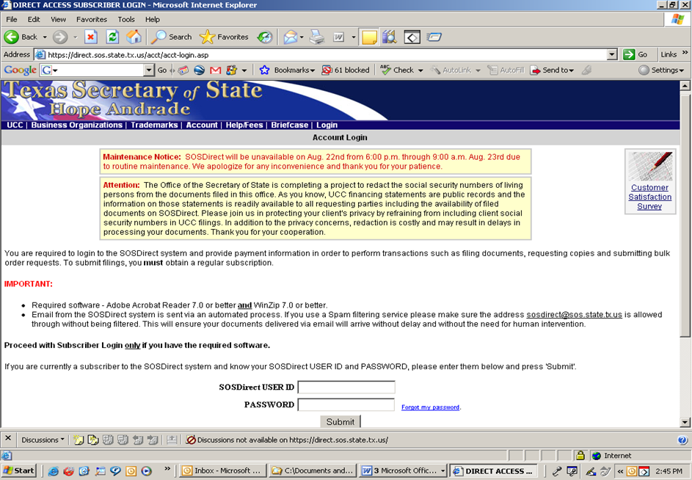

- Click on Business Organization.
- Click on Find – Entity.
- Enter the Legal Entity Name and click Search.
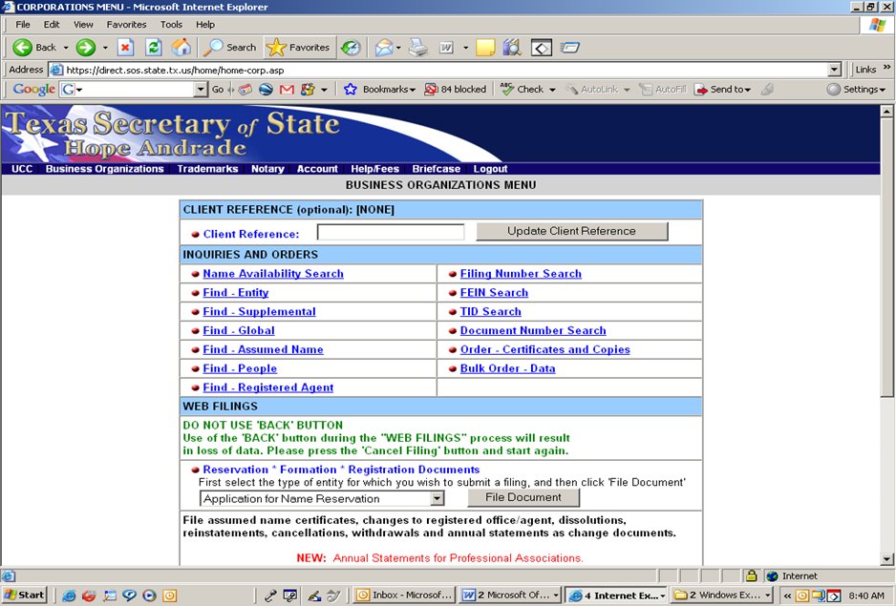

- On the Find Entity Name Search page, click on the Filing Number associated with the legal entity name.
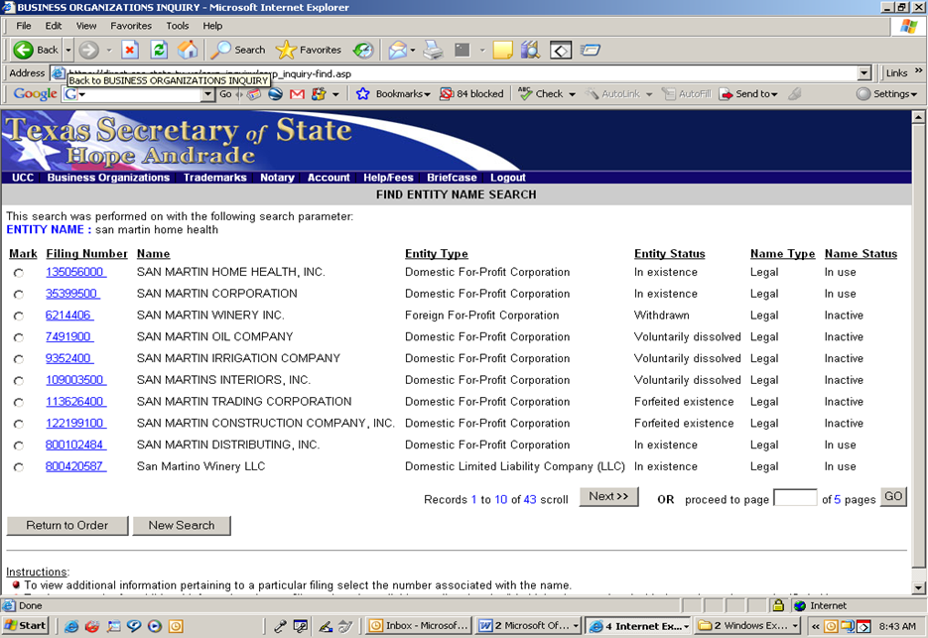

- Click on the Registered Agent tab to verify the information on the Business Organization Inquiry – View Entity Screen.
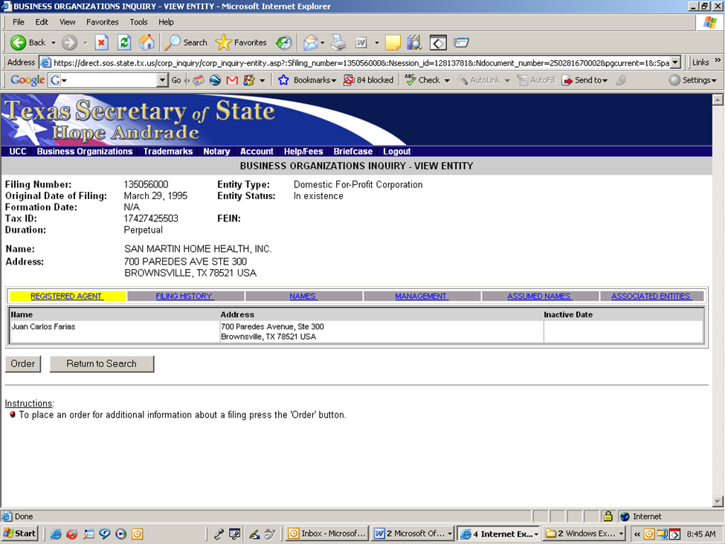

- If applicable, click on the Assumed Names tab.
- Verify the assumed name/DBA information for legal entities registered with the SOS.
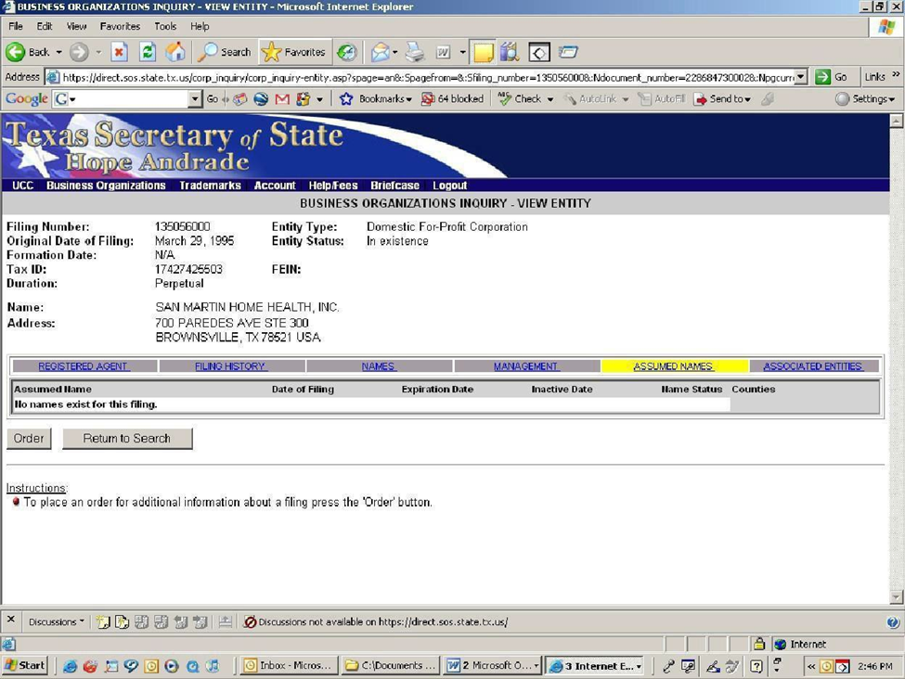
Following a search, staff will receive an automated packing slip (bill email). This service is free to governmental employees. Disregard the packing slip email, as no charge will be assessed.

Instructions for Completing Questions
To complete Questions 1-3 and, if applicable, Question 4, staff must access the SOS website at https://direct.sos.state.tx.us/acct/acct-login.asp
- If the legal entity is required to register with the Texas Secretary of State (SOS), is the entity status with the SOS “in existence”? – Refer to the SOS Business Organization Inquiry. Search by entity name. View the Entity screen. Print the screen and attach to the Form 5916.
  - If the entity status is registered as “in existence,” select Yes.
  - If the entity status is not registered as “in existence,” select No or, if the search by entity name shows “There are not records which match your inquiry,” select No and enter the entity status identified by the SOS or “No records match” in the Comments column.
- Is the legal entity’s legal name as it appears on the SOS website consistent with the legal entity’s legal name as it appears on Form 3254, Form 2039, other contractor enrollment documentation or in the Provider On-Line System or CARE? – Refer to the SOS Business Organization Inquiry. Search by entity name. View the Entity screen. Print the screen and attach to the Form 5916. Compare the results with the most recent Form 3254, Form 2039, contractor enrollment documentation, or Provider On Line System or Client Assignment and Registration System (CARE) information.
If the name identified by the SOS is:
  - The same as the provider’s legal name on record with HHSC, select Yes.
  - Not the same as the provider’s legal name on record with HHSC, or if the search by entity name shows “There are not records which match your inquiry,” select No and enter the legal name of the provider identified by the SOS or “No records match” in the Comments column.
- Is the legal entity type registered with the SOS consistent with the most current Form 2031, Form 2031-G or discontinued Forms 2031-A through E on file with HHSC? – Refer to the SOS Business Organization Inquiry. Search by entity name. View the Entity screen. Print the Screen and attach to the Form 5916. Compare the results to the provider’s most recent Form 2031, Form 2031-G or discontinued Forms 2031-a through E.
If the form on record with HHSC for the legal entity type is:
  - The correct form for the entity type identified by the SOS (refer to the Legal Entity Table on the next page), select Yes.
  - Not the correct form for the entity type identified by the SOS, or if the search by entity name shows “There are not records which match your inquiry,” select No and enter the legal entity type identified by the SOS or “No records match” in the Comments column.
Legal Entity Table
Entity Type | Form 2031 Before September 2008 | Form 2031 Sept. 1, 2008 Forward | Entity required to file with SOS | Entity required to register with Texas Comptroller
Corporations:  Not-for-profit  For profit  Professional | Form 2031, Corporate Board of Directors Resolution | Form 2031 Designation of Authorized Individual(s) – Business Entity | Yes | Yes
General Partnership | Form 2031-A, General Partnership Resolution | Form 2031, Designation of Authorized Individual(s) – Business Entity | No | No
Limited Partnership | Form 2031-B, Limited Partnership Resolution | Form 2031, Designation of Authorized Individual(s) – Business Entity | Yes | Yes
Limited Liability Partnership | Form 2031-C, Limited Liability Partnership Resolution | Form 2031, Designation of Authorized Individual(s) – Business Entity | Yes | Yes
Limited Liability Company | Form 2031-D, Members Resolution | Form 2031, Designation of Authorized Individual(s) – Business Entity | Yes | Yes
Hospital District or Hospital Authority | Form 2031-E, Hospital District Board of Directors | Form 2031-G, Designation of Authorized Individual(s) – Governmental Entity | No | No
Governmental Entities  - Local  - County  - State  - Council of government  - Other Governmental Entity | N/A | Form 2031-G, Designation of Authorized Individual(s) – Governmental Entity | No | No
Sole Proprietorship | N/A | N/A | No | No
Associations:  - Unincorporated not-for-profit associations  - Professional Associations  - Cooperative Associations | N/A | Form 2031, Designation of Authorized Individual(s) Governmental Entity | Yes | Yes
- If applicable, is the legal entity’s assumed name as it appears on the SOS website or assumed name certificate consistent with the legal entity’s DBA as it appears on Form 3681, Form 3254, Form 2039, Form 3602 or other contractor enrollment documentation?
  - If the legal entity is registered with the SOS – Refer to the SOS Business Organization Inquiry. Search by entity name. Vie the Entity Screen. Click on the Assumed Names tab. Print the screen and attach to the Form 5916. Compare the results with the entity’s assumed name (i.e., DBA) as it appears on Form 3681, Form 3254, Form 2039, Form 3602 or other contractor enrollment documentation.
If the assumed name identified by the SOS is:
  - the same as the DBA on record with HHSC, select Yes.
  - not the same as the DBA on record with HHSC, or if the search show “There are not records which match your inquiry,” select No and enter the assumed name identified by the SOS or “No records match” in the Comments column.
  - If the Legal entity is not registered with the SOS – Refer to the assumed name certificate on file with HHSC. If an assumed name certificate is not on file with HHSC, request a copy of the assumed name certificate from the legal entity. Compare the assumed name on the certificate with the entity’s DBA on Form 3681, Form 3254, Form 2039, Form 3602 or other contractor enrollment documentation.
If the assumed name identified by the assumed name certificate is:
  - the same as the DBA on record with HHSC, select Yes.
  - not the same as the DBA on record with HHSC, select No and enter the n assumed name certificate in the Comments column.
To answer Question 5, access the Texas Comptroller of Public Accounts (CPA) website at https://mycpa.cpa.state.tx.us/coa/Index.html.
- Is the legal entity’s franchise tax account status with the Texas Comptroller of Public Accounts (CPA) shown as Active? – Refer to the MyCPA website > Taxable Entity Search. Search by entity name.
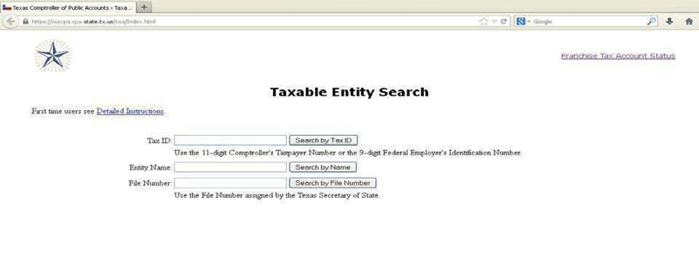

View the Entity screen. “Right to Transact Business in Texas” indicates an entity’s franchise tax account status. Print the screen and attach to the Form 5916.
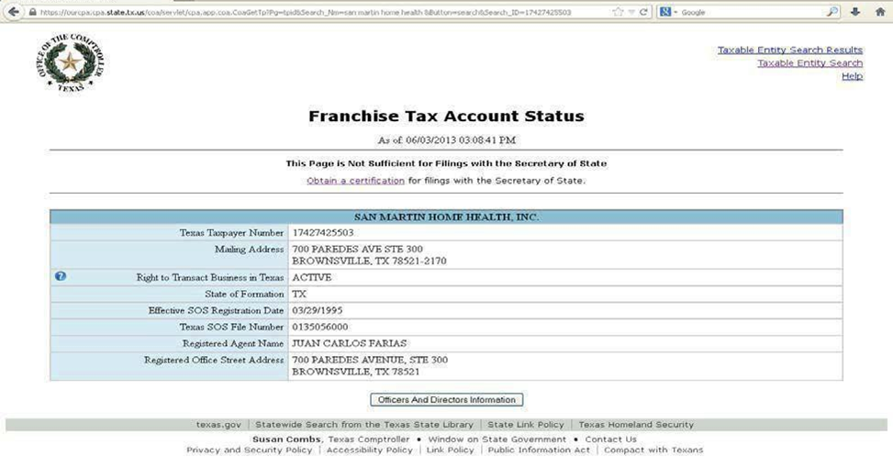
- If the legal entity’s Right to Transact Business in Texas status is listed as Active, select Yes.
- If the legal entity is not listed as Active, or if the CPA search shows “File number XXXXXXXXXX not found, “select No and enter the status (e.g., Eligible for Termination/Withdrawal, Forfeited, Not Established, Franchise Tax Ended or Franchise Tax Involuntarily Ended) or enter “File number not found” in the Comments column.
If the Right to Transact Business status is… | Then…
Active | The entity’s right to transact business in Texas is intact.
Eligible for Termination/Withdrawal | The entity has met franchise tax requirements to file for termination or withdrawal with the Texas Secretary of State.
Forfeited | The entity’s right to transact business in Texas is forfeited.
Not Established | The entity has not completed a franchise tax accountability questionnaire with the comptroller.
Franchise Tax Ended | The entity’s franchise tax responsibilities ended because the entity has ceased to exist in its state or country of formation or has ceased.
Franchise Tax Involuntarily | The entity’s registration or certificate was ended because of a tax forfeiture or an administrative forfeiture by the Texas Secretary of State.

To answer Question 6, access the CPA Vendor Performance Report Search website at http://www.txsmartbuy.com/vpts
- Does the CPA Vendor Performance System show the legal entity as having more than two contracts terminated by the state for unsatisfactory performance during the preceding three years?
  - If the search indicates the legal entity has had more than two contracts terminated by the state for unsatisfactory performance during the preceding three years, select Yes.
  - If the search does not indicate the legal entity has had more than two contracts terminated by the state for unsatisfactory performance during the preceding three years, select No.
To answer Questions 7-8, search each of the websites as well as the Health and Human Services (HHS) List of Exclusions Excel document (formerly known as the Debarment List), identified on the following:

Instructions for Checking the Legal Entity’s Debarment/Exclusion Status

Definitions for Debarment and Exclusion
Debarment is defined as the termination of rights to continue an existing contract; receive a new contract; participate as a provider or as an employee directly involved in administration of a contract; or make a bid offer, application or proposal for a contract. Debarment is for a specific length of time commensurate with the seriousness of the violation, the extent of the violation, prior impositions of sanctions or penalties, willingness to comply with program rules and directives, and other pertinent information.
Exclusion is defined as the prevention of individuals and entities from participating in federally funded health care programs.

Description of Debarment/Exclusion Databases/Reports
The List of Excluded Individuals/Entities (LEIE) – The U.S. Department of HHS – OIG, under congressional mandate, established a program to exclude individuals and entities from participating in federally funded health care programs and maintains a list of all currently excluded parties called the List of Excluded Individuals/Entities. Bases for exclusion include convictions for program-related fraud and patient abuse, licensing board actions, and default on Health Education Assistance Loans.
The HHSC – OIG was created by the 78th Texas Legislature to prevent and reduce waste, abuse and fraud within the Texas Health and Human Services System. A listing of all currently excluded parties is maintained by the OIG and is called the Texas Exclusions Database. Bases for exclusion include convictions for program-related fraud and patient abuse, licensing board action, U.S. Health and Human Services – OIG (Medicare) exclusion actions, and “permissive” exclusions as allowed by various legal authorities.
The System for Award Management (SAM) is a website which consolidates federal procurement systems and the Catalog of Federal Domestic Assistance. Currently, the Central Contractor Registry (CCR), Federal Agency Registration (FedReg), Online Representations and Certifications Application (ORCA), and Excluded Parties List System (EPLS) have been migrated into SAM. Over the coming years, additional system migrations will be completed.
The SAM website requires users to have Internet Explorer (IE) 11 or higher. To check which version you have, open your Internet browser. Click on Help from the menu bar, and then click on About Internet Explorer. A window will pop up that tells you which version you have. If you have IE 10 or lower, call in a help ticket to request Mozilla Firefox or Chrome and access SAM through that browser.
The U.S. Department of the Treasury Office of Foreign Assets Control (OFAC) Sanctions List Search database includes the following: Specially Designated Nationals and Blocked Persons list (“SDN List") and all other sanctions lists administered by OFAC, including the Foreign Sanctions Evaders List, the Non-SDN Iran Sanctions Act List, the Sectoral Sanctions Identifications List, the List of Foreign Financial Institutions Subject to Correspondent Account or Payable-Through Account Sanctions and the Non-SDN Palestinian Legislative Council List.
The HHS List of Exclusions has been compiled from various sources within the agency. The primary source is the adverse Action Review Committee (formerly referred to as the Sanction Action Review Committee). This list is currently distributed by Access and Eligibility Services – Eligibility Operations Provider Contract Management (AES – EOPCM) staff to all program areas required to check the list. The list does not include entities excluded or barred by Regulatory Services because of licensure violations/expirations. AES – EOPCM distributes the HHS List of Exclusions each time there is an update to the information.
The CPA Divestment Statute Lists include companies and organizations prohibited from contracting with the state of Texas. The list of companies and organizations is maintained by the Texas Safekeeping Trust Company and posted to the CPA website.

U.S. Department of Health and Human Services (HHS) – Office of Inspector General (OIG) – List of Excluded Individuals
Website: https://exclusions.oig.hhs.gov/
- Click the link
- Click on Search for a Single Entity and enter the legal entity’s name
- Save the search result page as an electronic file or print the screen and attach to the Form 5916
- Click on Search for Multiple Individuals and repeat the steps for the legal entity’s owners, partners, board members and other controlling persons

Texas Health and Human Services (HHS) – Office of Inspector General (OIG) – Exclusions Database
Website: https://oig.hhsc.state.tx.us/oigportal2/Exclusions
- Click on link
- Enter the legal entity’s (company’s) name
- Save the search result page as an electronic file or print the screen and attach to the Form 5916
- Repeat the steps for the legal entity’s owners, partners, board members and other controlling persons

System for Award Management (SAM)
Website: https://sam.gov/content/exclusions
- Click the link
- Click on Search Records on the home page – located on the right side of the main page of the website
- Enter the legal entity’s name in Quick Search and click on Search
- If the search returns several results, filter the results by Performance Information – on the left side of the page, under Filter Results > By Functional Area, select Performance Information and click Apply
- Save the search result page as an electronic file or print the screen and attach to the Form 5916
- Repeat the steps for the legal entity’s owners, partners, board members and other controlling persons

Comptroller of Public Accounts (CPA) Debarred Vendor List
Website: https://comptroller.texas.gov/purchasing/programs/vendor-performance-tracking/debarred-vendors.php
- Click the link
- Review the list of debarred vendors
- If the legal entity is on the list, save the list as an electronic file or print the list and attach to the Form 5916

U.S. Department of the Treasury – Office of Foreign Assets Control (OFAC) Sanctions Search List
Website: https://sanctionssearch.ofac.treas.gov/
- Search the OFAC Sanctions List Search Tool for the legal entity and any identified controlling persons of the legal entity, including the legal entity’s owners, partners and board members
- Enter the name(s) of the legal entity/individual(s) and TIM or Federal Taxpayer Identification Number (EIN or SSN) when completing the search
- Follow the OFAC “due diligence” steps (see OFAC Frequently Asked Question #5 to determine a valid OFAC match
- Save the search result pages as an electronic file or print the screen and attach to the Form 5916

Health and Human Services (HHS) List of Exclusions
Excel document
- Search the HHS List of Exclusions for the legal entity and any identified controlling persons of the legal entity for any debarment or application denial periods
- Enter the name(s) of the identified legal entity or controlling person, and the debarment or application denial period in the Comments section of the Form 5916

CPA Divestment Statute Lists (Texas Legislative Prohibitions)
Website: https://comptroller.texas.gov/purchasing/publications/divestment.php
- Check all the divestments lists maintained by the Comptroller of Public Accounts
- Select “Companies that Boycott Israel”
- Select “Scrutinized Companies with ties to Sudan”
- Select “Scrutinized Companies with ties to Iran”
- Select “Designated Foreign Terrorist Organizations”
- Select “Scrutinized Companies with ties to Foreign Terrorist Organizations”
- Save the search result pages as an electronic file or print the screen and attach to the Form 5916
- Is the legal entity or an owner/partner/board member/controlling person of the legal entity debarred/excluded from any federal or state program? – Refer to the Debarred/Excluded tables and the contractor enrollment documentation, Form 5871, Form 5871-S, discontinued Form 3603 or discontinued Form 3603-W. Search each website listed on the tables for debarred/excluded information by:
  - The legal entity name,
  - Owners,
  - Partners,
  - Board members, and
  - Other controlling persons
Search by the legal entity name as it appears on Form 3254, Form 2039, Form 3602 or in the Provider On Line System or CARE. Search the entity’s owners, partners, board members, and controlling persons as listed on the contractor enrollment documentation, Form 5871, Form 5871-S, discontinued Form 3603 or discontinued Form 3603-W. Save the search result page as an electronic file or print the screen and attach to the Form 5916.
  - If a record of exclusion or debarment is found on one or more of the websites or on the HHS List of Exclusions, select Yes and record the website(s) or report the name in the Comments column.
  - If a record of exclusion or debarment is not found on any of the websites or on the HHS List of Exclusions, select No.
- Is the legal entity on any of the CPA divestment lists? — Refer to each of the lists posted on the CPA website and the contractor enrollment documentation, Form 5871, Form 5871-S, discontinued Form 3603 or discontinued Form 3603-W. Search each list by the legal entity name.
Search by the legal entity name as it appears on Form 3254, Form 2039, Form 3602 or in the Provider On-Line System or CARE. Save each search result page as an electronic file or print the screens and attach to the Form 5916.

Instructions for Checking the Legal Entity’s Business Status
To answer questions 9 - 10, access the CPA Blue Zone at: https://comptroller.texas.gov/bluezone/bzweb52C2/Outside/TxCPA_launch_x.htm
Instructions for Requesting Access to the CPA Blue Zone: To request access to the CPA Blue Zone website, the staff’s manager/supervisor must fill out and submit the CPA access request form to the HHSC CPA Security Coordinator at: CPASecurityCoordinator@hhsc.state.tx.us.
Note the following when requesting access for staff:
  - Access Request Form – If teleworking, the HHSC CPA Security Coordinator will accept an electronic copy of the access request form, accompanied by the supervisor’s stated email approval (in lieu of a physical signature).
  - Access Mirroring – On the form, provide the name of an employee in your group from whom the HHSC CPA Security Coordination can mirror access.
  - User Identification – If the employee has had prior Comptroller systems access, provide their seven-character CPA User ID. If they have not had prior comptroller access and/or do not recall their User ID, the CPA’s office will instead require an SSN as their identifier. Access for new users cannot be set up without a Social Security number or a seven-character User ID. For new Web Warrant Inquiry and Cancellation Request (WWIC/TOSS) access requests, the employee TINS number is required by Treasury Operations. Access for new TINS users cannot be set up without an employee TINS number. If the manager/supervisor prefers, they may pass these numbers along in a secure manner via secure email or phone call.
  - Confidential Treatment of Information Acknowledgement (CTIA) – The new user gaining access to the CPA’s system(s) must also agree to the terms of the Confidential Treatment of Information Acknowledgement (CTIA) before the HHSC CPA Security Coordinator can process the request. Staff can access the CITA at: https://fmcpa.cpa.state.tx.us/ctia. Follow the instructions provided on this site and send confirmation to the HHSC CPA Security Coordinator when this has been completed.
  - Agency “529 – Health and Human Services Commission” must be selected from the Employing Agency drop-down menu. The HHSC CPA Security Coordinator cannot accept a CTIA signed for any other agency
  - Should staff encounter an error message when accessing this system in Internet Explorer, they should try using Google Chrome.
If staff needs assistance in requesting access to the CPA Blue Zone, contact the HHSC CPA Security Coordinator at: CpaSecurityCoordinator@hhsc.state.tx.us
- If the legal entity’s TIN has been established by the CPA, is the legal entity’s TIN the same one identified on the legal entity’s contract application or contract? – Search the CPA Blue Zone by the TIN as it appears on Form 3254, Form 2039, Form 3602 or in the Provider On Line System or CARE, as Follows:
  - Select link, click on “Secure TN3270E”; enter “USAS.”
  - Click “Enter”; Enter User Name, then “Tab” to enter password.
  - Click “Enter”; Select “9.”
  - Click “Enter”; Select “A.”
  - Click “Enter”; Enter the legal entity’s 11-digit TIN.
  - Click “Enter”; Result will display entity information.
Save the search result page as an electronic file or print the screen and attach to the Form 5916.
- Does “Payee Hold Information” for this legal entity exist? —Search the CPA Blue Zone by the TIN as it appears on Form 3254, Form 2039, Form 3602 or in the Provider On-Line System or CARE, as follows:
  - Select link, click on “Secure TN3270E”; enter “USAS.”
  - Click “Enter”; Enter User Name, then “Tab” to enter password.
  - Click “Enter”; Select “9.”
  - Click “Enter”; Select “D.”
  - Click “Enter”; Enter the legal entity’s 11-digit TIN.
  - Click “Enter”; Result will display “Payee Hold Information” or “No Payee Hold Information Exists.”
Save the search result page as an electronic file or print the screen and attach to the Form 5916.
To answer Question 11, access the Public Access to Court Electronic Records (PACER) database at https: https://pacer.login.uscourts.gov/csologin/login.jsf?court_id=00pcl.
The PACER system requires users to register to search the PACER database, and its use should be limited to official state-approved business.
If staff does not have an account set up with the PACER system, they must do the following:
- Go to https://pacer.login.uscourts.gov/cgi-bin/login.pl?court_id=00pcl.
- Click on Need an account?
- Enter information in every field marked with an asterisk (*).
- Click on Check here if you are registering as a U.S. Government Agency.
- Skip the credit card information section.
- Enter the security question.
- Click on Check here to acknowledge you have read and understand the Policies and Procedures listed above.
- Submit the form.
Staff will receive their login and password in the mail within a week. For security reasons, logins and passwords cannot be emailed, faxed or given over the phone. If staff has any questions, they must call the PACER Service Center at 1-800-676-6856. To maintain security, the password must be changed every 90 days, or immediately should it become compromised.
PACER charges 10 cents per page retrieved. This applies to both pages of search results and the pages of documents staff retrieves. If staff accrues a total of less than $15 worth of charges in any given quarter, fees are waived for that quarter. Should staff receive a bill, it would be handled according to local processes for accounts receivable and be paid through staff’s department’s budget.
- Is the legal entity or owner, if a sole proprietor, listed in the bankruptcy filings in the Public Access to Court Electronic Records (PACER) database?
  - Enter the PACER login and password.
  - Select the Bankruptcy tab.
  - Skip Case Search.
  - Go to Party Search.
  - In the SSN/TIN box, search by entering the federal tax ID (9-digit number) of the legal entity or the Social Security number of the owner, if a sole proprietor.
    - If the legal entity or owner is listed in the PACER database and the case has not been dismissed or discharged, select Yes and consult with Legal Services – Litigation staff by sending an email to HHSCComplexLitigation@hhsc.state.tx.us. Save email correspondence as an electronic file or print the correspondence and attach to the Form 5916.
    - If the legal entity or owner is listed in the PACER database and the case has been dismissed or discharged, select No.
    - If the legal entity or owner is not listed in the PACER database, select No.

Instructions for Checking the Legal Entity’s Employability Status
To answer Question 12, access the HHSC Employability Status Database at, https://emr.dads.state.tx.us/DadsEMRWeb/emrRegistrySearch.jsp
- Is an owner or a partner/member/managing employee/controlling person of the legal entity listed in the HHSC Employability Status Database as unemployable in the state of Texas? – Refer to Form 5871, Form 5871-S, discontinued Form 3603 or discontinued Form 3603-W.
Search the website for the entity’s owners and partners/members, managing employees and controlling persons as listed on Form 5871, Form 5871-S, discontinued Form 3603 or discontinued Form 3603-W. For the best results, use Social Security numbers. Save the search result page as an electronic file or print the screen and attach to the Form 5916.
  - If an owner or a partner/member/managing employee/controlling person is identified as unemployable, select Yes and record the name(s) of the individual(s) and the registry(ies) in the Comments column.
  - If an unemployable match is not found in the Employability Status Database, select No.

Instructions for Checking the Legal Entity’s Medicaid Enrollment Status
Question 13 applies to Medicaid contract applicants/contractors and is therefore not applicable to AFC, ERS, Guardianship, HDM and RC contracts.
To complete Question 13, access the Social Security Death Master File via the GlobalScape or the Centers for Medicare & Medicaid Services (CMS) Data Exchange System (DEX) and access the CMS Adverse Actions Report via DEX.
Instructions for Requesting Access to GlobalScape: Only state office contract enrollment staff is granted access to the Social Security Death Master File. To gain access to the file, state office contract enrollment staff must follow the link below and follow the request instructions located on the website: https://hhsconnection.hhs.texas.gov/it/network-system-access/secure-ftp-globalscape
Staff should request access to GlobalScape folder: /Ufr/dads_cos. If staff need additional assistance with the request, refer to the Help contacts as outlined on the site.
Instructions for Requesting Access to DEX: To access DEX, staff must first request access to the CMS Enterprise Identity Management (EIDM) Portal. EIDM is the system that connects users to all the CMS applications with one central user ID.
To sign up for an EIDM User ID, staff must go to the CMS Enterprise Portal at https://portal.cms.gov, choose “New User Registration,” then complete the following steps:
- Use the drop-down menu to choose “DEX: Data Exchange System”, agree to the terms and conditions by checking the box and click “Next.”
- Enter personal information and click “Next.”
- Select a User ID and password and set challenge questions. Click “Next.”
- Review registration information. Click “Submit User.”
- Staff will receive an email confirming your registration. Upon receipt, users can request access to DEX.
To request access to DEX, staff must complete the following steps:
- Log in to their account on the CMS Enterprise Portal at https://portal.cms.gov with their EIDM user name and password.
- Click “Request/Add Apps.”
- Scroll down to the Data Exchange System (DEX) application box and select “Request Access.”
- Use the drop-down menu to identify the state user role (Reporting and Screening).
- Enter information and click “Next.”
- Select their state by clicking the state name followed by the blue arrow to move it to the box on the right.
- Review all of the entered information. If it is correct, click “Submit.”
- Staff will see a Request New Access Application Acknowledgement and tracking number. Click “OK.” Keep the tracking number.
The DEX administrator for Texas will review and approve staff’s DEX user requests.
- For Medicaid contract applicants/contractors, is an owner or a partner/member/managing employee/controlling person of the legal entity listed in one of the following?
  - Social Security Death Master File?
  - CMS Adverse Actions Report?
Save the search result page as an electronic file or print the screen and attach to the Form 5916.
  - If an owner or a partner/member/managing employee/controlling person of the legal entity is listed in the file or on the report, select Yes, then contact the legal entity representative to obtain updated ownership information removing the deceased or listed party from ownership.
  - If the legal entity representative fails to provide updated ownership information by the required due date:
    - For a prospective contract: Do not award the contract.
    - For an active contract: Start contract termination and maintain copies of all correspondence.
  - If an owner is not listed in the file or on the report, select No.
To complete Question 14, contract staff must verify the legal entity’s NPI by searching the NPPES NPI Registry site at https://npiregistry.cms.hhs.gov/.
- Is the legal entity’s NPI listed in the CMS National Plan and Provider Enumeration System (NPPES)?
Search by NPI as it appears on Form 3254, Form 2039, Form 3602 or in the Provider On Line System or CARE. Save the search result page as an electronic file or print the screen and attach to the Form 5916.
  - If the NPI does not appear in the NPPES NPI Registry, consult with management staff for further direction.

Instructions for Checking the Legal Entity’s Licensure Status
Questions 15 – 22 are not applicable to AFC homes with three or fewer beds, CDS, CLASS – Case Management Agency (CLASS – CMA), ERS, Guardianship, HDM, Swing Beds and TAS contracts, a change in ownership interest of less than 50% or a change in the business organization structure of the legal entity.
Complete only the question applicable to the legal entity being screened.
Staff must verify the status of the license by searching the Texas Unified Licensure Information Portal (TULIP) or accessing the Long-Term Care Regulatory (LTC-R) HCSSA Integrated System.
For all search results, save a copy of the license and the search result page as electronic files or attach the copy of the license and the search result page to the Form 5916.
To gain access to TULIP: Contract staff must send an email to DMA@hhsc.state.tx.uus as the required form is only available by request. Regulatory Services will provide the required form and set up read-only access to TULIP once the completed form has been returned.
Refer to the following tables for the License/certification required for a particular contract type and Verify the legal entity has the appropriate category/service type of licensure/certification.
Facility Licensure | Contract Types
Adult Day Care or Day Activity and Health Services (DAHS) License | DAHS  PACE
Assisted Living License Type A or B | CCAD-AFC (5, 6, 7 or 8 beds)  DBMD  CCAD-RC
Assisted Living License Type C | CCAD – AFC (4 beds)
ICF/IID License | ICF/IID
NF License | NF

HCSSA Licensure | Contract Types
Licensed Home Health Services | CLASS – Direct Services Agency (DSA)
Licensed and Certified Home Health Services | CLASS – DSA  DBMD  PHC/FC/CAS
Licensed to Provide Personal Assistance | PHC/FC/CAS
Licensed to Provide Hospice Services | Hospice

Certification | Contract Types
Medicaid Certification | NF
Medicare Certification | ICF/IID
Regulatory Services – Waiver Survey & Certification | HCS  TxHmL
The following contract types do not require a license or certification:
- CCAD – AFC (3 or fewer beds
- CDS
- CLASS – CMA
- ERS
- HDM
- Swing Beds (requires a letter of approval from Regulatory Services
- TAS
- For a Home and Community Support Services Agency (HCSSA), does the legal entity have a current HCSSA License? – Access TULIP or access the Long-Term Care Regulatory (LTC-R) HCSSA Integrated System (to verify the legal entity has a current HCSSA license. Staff should verify that the provider has maintained the license for all contracted counties. If additional space is needed (i.e., if the legal entity has more than one HCSSA License), enter the additional license information on the last page of the Screening Criteria form.
  - If the license is current, select Yes and enter the license number and the license expiration date in the Comments column.
  - If the license is not current, select No and enter the license number and license expiration date in the Comments column.
    - For a prospective contract, do not award the contract.
    - For an active contract, begin contract termination.
  - For a Renewal or CHOW in Process, select the applicable box.
    - For a prospective contract:
      - Contact Regulatory Services, Licensing and Certification at 512-438-2630 to request the expected date of completion.
      - Pend award of the contract.
    - For an active contract:
      - Contact Regulatory Services, Licensing and Certification at 512-438-2630 to request the expected date of completion.
      - Conduct the contract monitoring review as scheduled.
    - For a Propose to Deny License or an Enforcement Action Pending (EAP), select the applicable box.
      - For a prospective contract (e.g., enrollment – new contract type, CHOW) pend award of the contract.
    - For an active contract:
      - Contact Regulatory Services, Provider Licensing Enforcement Unit at 512-438-4860 to request the status of the enforcement action.
      - Conduct the contract monitoring review as scheduled
- For a hospice contractor, does the legal entity have a current HCSSA license and Medicare certification? – Access the Texas Unified Licensure Information Portal (TULIP) or access the LTC-R HCSSA Integrated System to verify the legal entity has a current HCSSA license. Contact Regulatory Services, Licensing and Certification at 512-438-2630 to verify the legal entity has a current Medicare certification. Staff should verify that the provider has maintained the license for all contracted counties. If additional space is needed (i.e., if the legal entity has more than one HCSSA license), enter the additional license information on the last page of the Screening Criteria form.
  - If the license and Medicare certification are both current, select Yes and enter the license number and license expiration date in the Comments column.
  - If the license or Medicare certification is not current, select No and enter the License number and license expiration date in the Comments column.
    - For a prospective contract, do not award the contract.
    - For an active contract, contact Regulatory Services, Licensing and Certification at 512-438-2630 and request to speak to a hospice licensing specialist before you begin contract termination.
  - For a Renewal or CHOW in Process, select the applicable box.
    - For a prospective contract:
      - Contact Regulatory Services, Licensing and Certification at 512-438-2630 to request the expected date of completion.
      - Pend award of the contract.
    - For an active contract:
      - Contact Regulatory Services, Licensing and Certification at 512-438-2630 to request the expected date of completion.
      - Conduct the contract monitoring review as scheduled.
  - For a Propose to Deny License or an EAP, select the applicable box.
    - For a Prospective contract (e.g., enrollment – new contract type, CHOW), pend award of the contract.
    - For an active contract:
      - Call Regulatory Services, Provider Licensing Enforcement Unit at 512-438-4860 to request the status of the enforcement action.
      - Conduct the contract monitoring review as scheduled.
- For a Day Activity and Health Services (DAHS) facility, does the legal entity have a current License? – Access the Texas Unified Licensure Information Portal (TULIP) to verify the legal entity has a current license.
  - If the license is current, select Yes and enter the facility ID number and the license expiration date in the Comments column.
  - If the license is not current, select No and enter the facility ID number and the license expiration date in the Comments column.
    - For a prospective contract, do not award the contract.
    - For an active contract, begin contract termination.
  - For a Renewal or CHOW in Process, select the applicable box.
    - For a prospective contract:
      - Contact Regulatory Services, Provider Licensing Enforcement Unit at 512-438-4860 to request the expected date of completion.
      - Pend award of contract.
    - For an active contract:
      - Contact Regulatory Services, Licensing and Certification at 512-438-2630 to request the expected date of completion.
      - Conduct the contract monitoring review as scheduled.
  - For a Propose to Deny License or an EAP, select the applicable box.
    - For a prospective contract (e.g., enrollment – new contract type, CHOW), pend award of the contract.
    - For an active contract:
      - Call Regulatory Services, Provider Licensing Enforcement Unit at 512-438-4860 to request the status of the enforcement action.
      - Conduct the contact monitoring review as scheduled.
- For a Residential Care (RC) provider or an Adult Foster Care (AFC) provider with 4 or more beds, does the legal entity have a current Assisted Living License? – Access the Texas Unified Licensure Information Portal (TULIP) to verify the legal entity has a current license.
  - If the license is current, select Yes and enter the facility ID number and the license expiration date in the Comments column.
  - If the license is not current, select No and enter the facility ID number and the license expiration date in the Comments column.
    - For a prospective contract, do not award the contract.
    - For an active contract, begin contract termination.
  - For a Renewal or CHOW in Process, select the applicable box.
    - For a prospective contract:
      - Contact Regulatory Services, Licensing and Certification at 512-438-2630 to request the expected date of completion.
      - Pend award of the contract.
    - For an active contract:
      - Contact Regulatory Services, Licensing and Certification at 512-438-2630 to request the expected date of completion.
      - Conduct the contract monitoring review as scheduled.
  - For a Propose to Deny License or an EAP, select the applicable box.
    - For a prospective contract (e.g., enrollment – new contract type, CHOW), pend award of the contract.
    - For an active contract:
      - Call Regulatory Services, Provider Licensing Enforcement Unit at 512-438-4860 to request the status of the enforcement action.
      - Conduct the contract monitoring review as scheduled.
- For a Nursing Facility (NF) is the NF contractor currently licensed and Medicaid certified? – In order to be an NF contractor, the facility must first apply for a license and obtain Medicaid certification. Contact Regulatory Services, Licensing and Certification at 512-438-2630 to obtain the facility ID number, the license expiration date and Medicaid certification information.
  - If the license and Medicaid certification are both current, select Yes and enter the facility ID and the license expiration date in the Comments column.
  - If the license or Medicaid certification is not current, select No and enter the facility ID and the license expiration date in the Comments column.
    - For a prospective contract, do no award the contract.
    - For an active contract, begin contract termination.
  - For a Renewal or CHOW in Process, select the applicable box.
    - For a prospective contract:
      - Contact Regulatory Services, Licensing and Certification at 512-438-2630 to request the expected date of completion.
      - Pend award of the contract.
    - For an active contract:
      - Contact Regulatory Services, Licensing and Certification at 512-438-2630 to request the expected date of completion.
      - Conduct the contract monitoring review as scheduled.
  - For a Propose to Deny License or an EAP, select the applicable box.
    - For a prospective contract (e.g., enrollment – new contract type, CHOW), pend award of the contract.
    - For an active contract:
      - Call Regulatory Services, Provider Licensing Enforcement Unit at 512-438-4860 to request the status of the enforcement action.
      - Conduct the contract monitoring review as scheduled.
- For an Intermediate Care Facility for Individuals with an Intellectual Disability or Related Conditions (ICF/IID), is the contractor currently certified as an ICF/IID and, if applicable, licensed? — Contact Regulatory Services, Licensing and Certification at 512-438-2630 to obtain the facility ID, the license expiration date and Medicare certification information.
  - If the license and ICF/IID certification are both current, select Yes and enter the license number and expiration date in the Comments column.
  - If the license or ICF/IID certification is not current, select No and enter the license number and expiration date in the Comments column.
    - For a prospective contract, do not award the contract.
    - For an active contract, begin contract termination.
  - For a Renewal or CHOW in Process, select the applicable box.
    - For a prospective contract:
      - Contact Regulatory Services, Licensing and Certification at 512-438-2630 to request the expected date of completion.
      - Pend award of the contract.
    - For an active contract:
      - Contact Regulatory Services, Licensing and Certification at 512-438-2630 to request the expected date of completion.
      - Conduct the contract monitoring review as scheduled.
  - For a Propose to Deny License or an EAP, select the applicable box.
    - For a prospective contract (e.g. enrollment – new contract type, CHOW), pend award of the contract.
    - For an active contract:
      - Call Regulatory Services, Provider Licensing Enforcement Unit at 512-438-4860 to request the status of the enforcement action.
      - Conduct the contract monitoring review as scheduled.
- For a Home and Community-based Services (HCS) provider, is the legal entity currently certified as an HCS program provider? — Contact Regulatory Services, Waiver Survey and Certification, at 512-438-4163 to obtain certification information.
  - If the entity is currently certified, select Yes.
  - If the entity is not currently certified, select No.
    - For a prospective contract, do not award the contract.
    - For an active contract, begin contract termination.
  - For a Renewal or CHOW in Process, select the applicable box.
    - For a prospective contract:
      - Contact Regulatory Services, Waiver Survey and Certification, at 512-438-4163 to request the expected date of completion.
      - Pend award of the contract.
    - For an active contract:
      - Contact Regulatory Services, Waiver Survey and Certification, at 512-438-4163 to request the expected date of completion.
      - Conduct the contract monitoring review as scheduled.
  - For a Propose to Deny License or an EAP, select the applicable box.
    - For a prospective contract (e.g., enrollment – new contract type, CHOW), pend award of the contract.
    - For an active contract:
      - Call Regulatory Services, Waiver Survey and Certification, at 512- 438-4163 to request the status of the enforcement action.
      - Conduct the contract monitoring review as scheduled.
- For a Texas Home Living (TxHmL) provider, is the legal entity currently certified as a TxHmL program provider? — Contact Regulatory Services, Waiver Survey and Certification, at 512-438-4163 to obtain certification information.
  - If the entity is currently certified, select Yes.
  - If the entity is not currently certified, select No.
    - For a prospective contract, do not award the contract.
    - For an active contract, begin contract termination.
  - For a Renewal or CHOW in Process, select the applicable box.
    - For a prospective contract:
      - Contact Regulatory Services, Waiver Survey and Certification, at 438-4163 to request the expected date of completion.
      - Pend award of the contract.
    - For an active contract:
      - Contact Regulatory Services, Waiver Survey and Certification, at 512-438-4163 to request the expected date of completion.
      - Conduct the contract monitoring review as scheduled.
  - For a Propose to Deny License or an EAP, select the applicable box.
    - For a prospective contract (e.g., enrollment – new contract type, CHOW), pend award of the contract.
    - For an active contract:
      - Call Regulatory Services, Waiver Survey and Certification, at 512-438-4163 to request the status of the enforcement action.
      - Conduct the contract monitoring review as scheduled.

